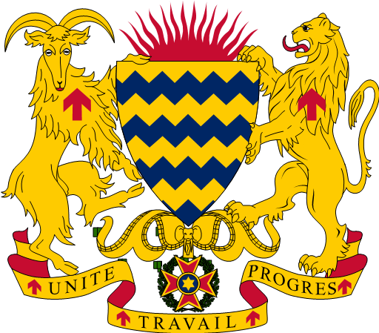

Attributions of the President of the Transitional Military Council, President of the
Republic, Head of State
(P.T.M.C.)

EXTRACT FROM THE TRANSITION CHARTER OF THE REPUBLIC OF CHAD

Article 37: The President of the Transitional Military Council occupies the functions of the President
of the Republic, Head of State and Supreme Commander of the Armed Forces.
It ensures compliance with the Transition Charter,
He is the Head of Administration.
He ensures, through his arbitration, the functioning of the public authorities as well as the continuity
of State.
It legislates by way of ordinance the cases provided for by law.
Article 38: The President of the Military Council is the guarantor of national unity,
national independence and the judiciary, territorial integrity and respect for
international treaties and agreements to which Chad is a party.
Article 39: The President of the Transitional Military Council presides over the Military Council of
Transition, the Council of Ministers, the Higher Defense Councils and Committees
national.
Article 40: The President of the Transitional Council promulgates the laws adopted by the Council
National de Transition within 15 days of their transmission.
Within this period, the President of the Transitional Military Council may request a second
reading. This new deliberation takes place within a period not exceeding eight days.
Article 41: The President of the Transitional Military Council accredits ambassadors and
extraordinary envoys.
Article 42: The President of the Transitional Military Council exercises the right of pardon.
He confers the decorations of the Republic.
Article 43: The President of the Transitional Military Council appoints by decree to the high
civil and military functions of the State.
Article 44: The President of the Transitional Military Council may delegate some of his
powers to Ministers.
Article 45: The functions of President of the Transitional Military Council are incompatible
with the exercise of any paid public or private employment.
Article 46: In the event of impediment or temporary absence of the President of the Military Council
the interim is provided by the Vice-Chairman of the said Board.
Article 47: Acts of the President of the Transitional Military Council other than those relating to:
- The appointment and dismissal of members of the Transitional Military Council;
- On the appointment and dismissal of the Prime Minister;
- To the appointment and dismissal of members of the major institutions of the Republic;
- At the dissolution of the National Transitional Council;
- The exercise of exceptional powers;
- To messages sent by him to the National Transitional Council;
- Upon referral to the Supreme Court;
- The right of pardon;
- To simple decrees,
Are countersigned by the Prime Minister and, where appropriate, by the responsible ministers.

